***First Order Differential Equations***

***Section* 2.7 – First-Order Linear Equations**

**General First-Order Differential Equations and Solutions**

A ***first-order differential equation*** is an equation



In which  is a function of two variables defined on a region in the *xy*-plane.

***Example***

Show that every member of the family of functions  is a solution of the first-order differential equation  on the interval (0, ∞), where *C* is any constant.

***Solution***













 **√**

Therefore, for every value of C, the function  is a solution of the first-order differential equation .

***Example***

Show that the function  is a solution of the first-order initial value problem .

***Solution***

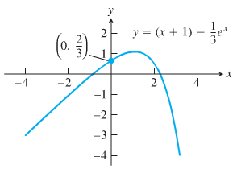













***Slope Fields*: Viewing Solution Curves**

Each time we specify an initial condition  for the solution of a differential equation , the solution curve is required to pass through the point  and to have a slope  there.

What we draw a lineal element at each point  with slope  then the collection of these lineal elements is called a ***direction field*** or a ***slope field*** of the differential equation.

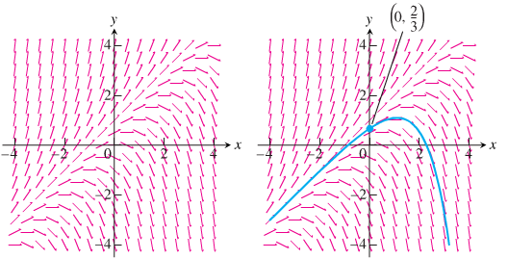

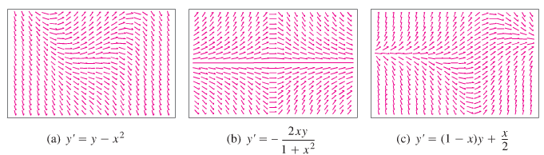

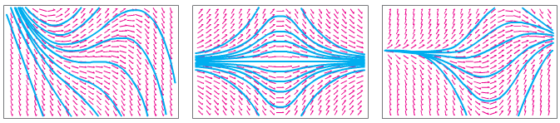

***Euler’s Method***

***Euler's method*** named after *Leonhard Euler* is an example of a ***fixed-step*** solver.

Euler's method is a first-order numerical procedure for solving ordinary differential equations (ODEs) with a given initial value. It is the most basic kind of explicit method for numerical integration of ordinary differential equations.

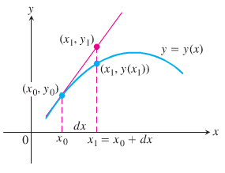 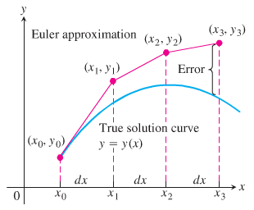

 

The setting size: 

Then, 





*Last point* 

By the definition of the derivative:





The tangent line at the point  is:







This method is known as *Euler's Method* with step size *h*.

***Example***

Find the first three approximations  using Euler’s method for the initial value problem



Starting at  with *dx* = 0.1.

***Solution***

























***Example***

Use Euler’s method to solve



On the interval , starting at  and taking

1. *dx* = 0.1.
2. *dx* = 0.05.

Compare the approximations with the values of the exact solution 

***Solution***

1. Euler Method ***dx* = 0.1**

***t Approx. Exact Difference***

----------------------------------------------------------------

0.00 | 1.00000000 | 1.00000000 | 0.00000000

0.10 | 1.20000000 | 1.21034184 | 0.01034184

0.20 | 1.42000000 | 1.44280552 | 0.02280552

0.30 | 1.66200000 | 1.69971762 | 0.03771762

0.40 | 1.92820000 | 1.98364940 | 0.05544940

0.50 | 2.22102000 | 2.29744254 | 0.07642254

0.60 | 2.54312200 | 2.64423760 | 0.10111560

0.70 | 2.89743420 | 3.02750541 | 0.13007121

0.80 | 3.28717762 | 3.45108186 | 0.16390424

0.90 | 3.71589538 | 3.91920622 | 0.20331084

1.00 | 4.18748492 | 4.43656366 | 0.24907874

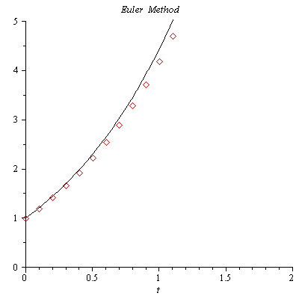

1. Euler Method ***dx* = 0.05**

***t Approx. Exact Difference***

----------------------------------------------------------------

0.00 | 1.00000000 | 1.00000000 | 0.00000000

0.05 | 1.10000000 | 1.10254219 | 0.00254219

0.10 | 1.20500000 | 1.21034184 | 0.00534184

0.15 | 1.31525000 | 1.32366849 | 0.00841849

0.20 | 1.43101250 | 1.44280552 | 0.01179302

0.25 | 1.55256313 | 1.56805083 | 0.01548771

0.30 | 1.68019128 | 1.69971762 | 0.01952633

0.35 | 1.81420085 | 1.83813510 | 0.02393425

0.40 | 1.95491089 | 1.98364940 | 0.02873851

0.45 | 2.10265643 | 2.13662437 | 0.03396794

0.50 | 2.25778925 | 2.29744254 | 0.03965329

0.55 | 2.42067872 | 2.46650604 | 0.04582732

0.60 | 2.59171265 | 2.64423760 | 0.05252495

0.65 | 2.77129828 | 2.83108166 | 0.05978337

0.70 | 2.95986320 | 3.02750541 | 0.06764222

0.75 | 3.15785636 | 3.23400003 | 0.07614367

0.80 | 3.36574918 | 3.45108186 | 0.08533268

0.85 | 3.58403664 | 3.67929370 | 0.09525707

0.90 | 3.81323847 | 3.91920622 | 0.10596775

0.95 | 4.05390039 | 4.17141932 | 0.11751893

1.00 | 4.30659541 | 4.43656366 | 0.12996825

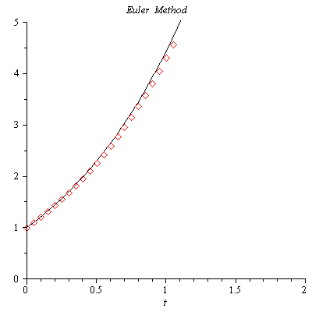

A ***first-order linear*** differential equation is one that can be written in the ***standard form***



Where *P* and *Q* are continuous functions of *x*

**Solving Linear Equations**

We solve the equation 

**Separable Equation**

***Solution of the homogenous equation***





 ***Integrate both sides***

 ***Convert to exponential form***





***Example***

Solve the differential equation 

***Solution***









 *Cross multiplication*



***General Method***

1. Separate the variables
2. Integrate both sides
3. Solve for the solution , if possible

***Example***

Find the general solution of the differential equation. 

***Solution***



 











***Solution of the Nonhomogeneous Equation ***

Let assume:  

The homogeneous equation is given by 











 *Since* 





















***Example***

Solve the equation 

***Solution***













***Example***

Solve the equation , satisfying 

***Solution***





|  |  |
| --- | --- |
|  |  |







 



***Exercises Section* 2.7 – First-Order Linear Equations**

Write an equivalent first-order differential equation and initial condition for *y*.

|  |  |
| --- | --- |
|  |  |

(**3 − 6**) Use Euler’s method to calculate the first three approximations to the given initial value problem for the specified increment size. Calculate the exact solution and investigate the accuracy of your approximations. Round the results to four decimals

|  |  |
| --- | --- |
|  |  |

1. Use the Euler method with  to estimate  if  and . What is the exact value of ?
2. Use Euler’s Method to solve  on the interval  and taking . Compare the approximation to the values of the exact solution.
3. Use Euler’s Method to solve  on the interval  and taking . Compare the approximation to the values of the exact solution.

(**10 − 16**) Verify that the given function *y* is a solution of the differential equation that follows it. Assume that  are arbitrary constants.

1. 
2. 
3. 
4. 
5. 
6. 
7. 

(**17 − 20**) Verify that the given function *y* is a solution of the initial value problem that follows it.

1. 
2. 
3. 
4. 

(**21 − 104**) Solve the differential equations

|  |  |  |  |
| --- | --- | --- | --- |
|  |  | | |
|  | |  |

(**105 − 202**) Solve the initial value problem

|  |  |  |
| --- | --- | --- |
|  |  | |
|  | |  |